OUTPUT OF PRATICAL ASSIGNMENT
ASSIGNMENT -1

OUTPUT 1


OUTPUT 2
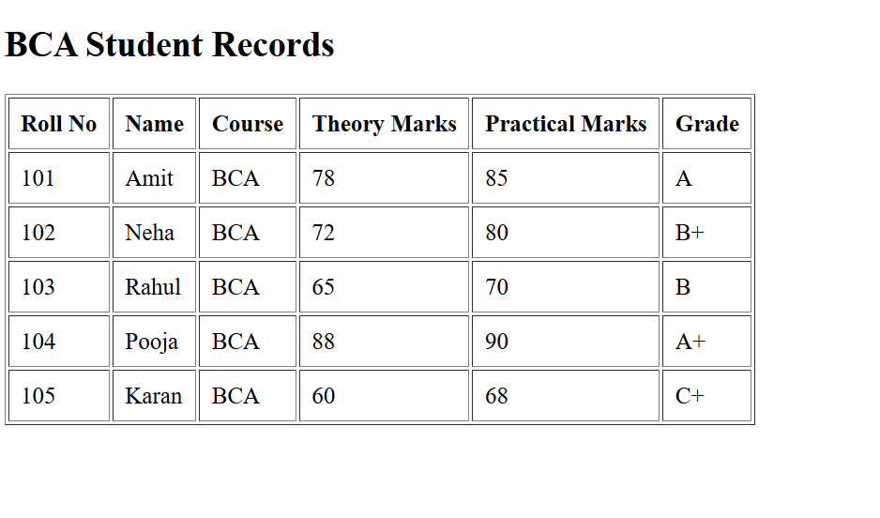
OUTPUT 3
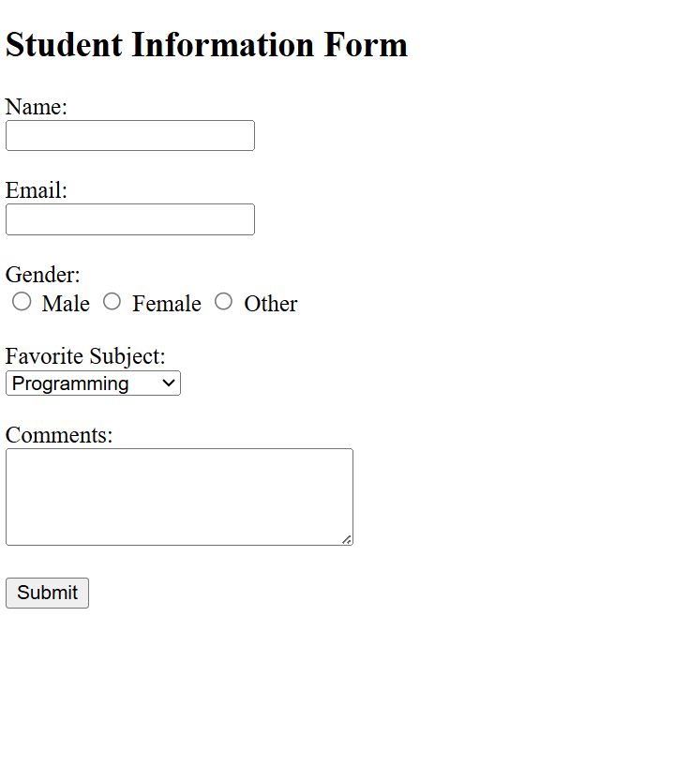
OUTPUT 4

OUTPUT 5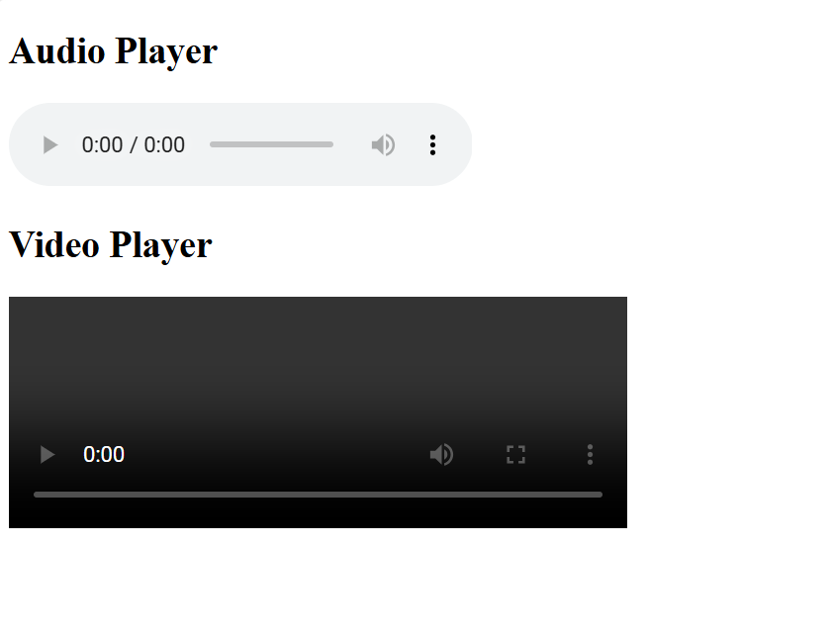

ASSIGNMENT-2

OUTPUT 1
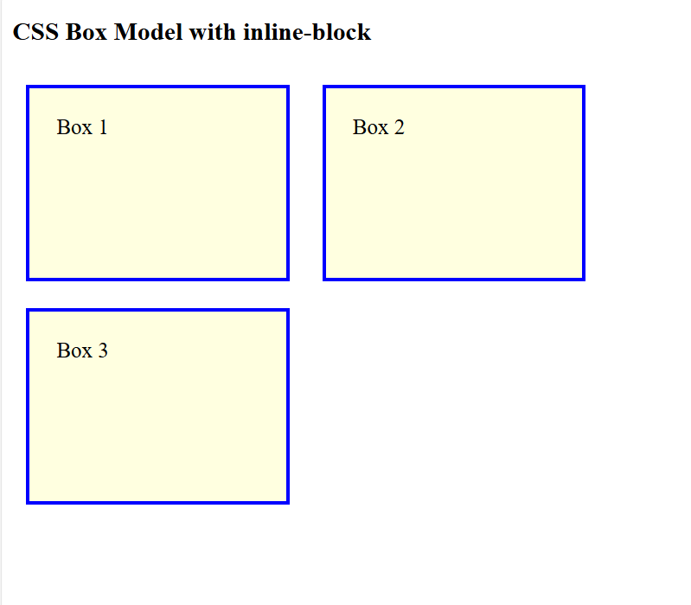
OUTPUT 2
OUTPUT 3
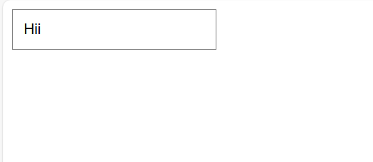
ASSIGNMENT-3
OUTPUT 1
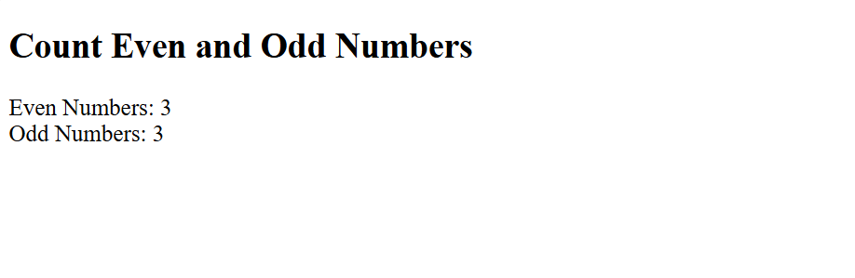OUTPUT 2
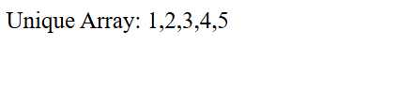

OUTPUT 3
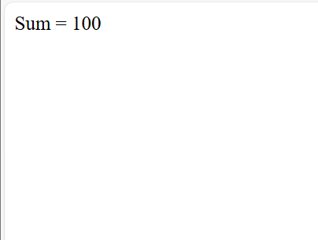

ASSIGNMENT-4
OUTPUT 1
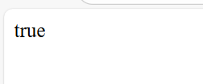
OUTPUT 2 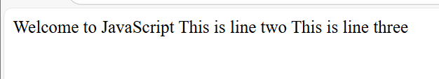
OUTPUT 3
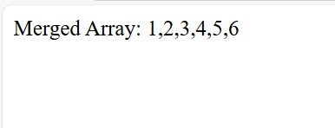

OUTPUT 4
